**PRACTICAL NO: 10**

# **Aim:** install run and configure apache solr

# **Steps**:

Apache Solr is a powerful, open-source search platform built on Apache Lucene. Below are the steps to install, run, and configure Apache Solr on a Linux-based system.

## **1. Install Apache Solr**

### **Prerequisites**

* Java 8 or later (OpenJDK or Oracle JDK)
* At least 2GB RAM for optimal performance
* A Linux system (Ubuntu/Debian, CentOS, or macOS/Windows)

### **Install Java**

Check if Java is installed:

java -version

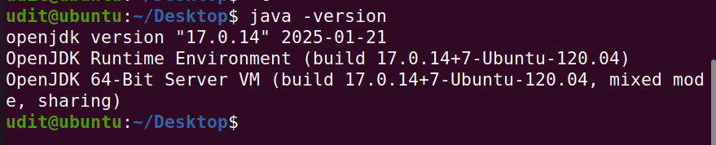

If Java is not installed, install OpenJDK:

sudo apt update

sudo apt install openjdk-17-jdk -y

Verify Java installation:

java -version

### **Download Apache Solr**

Go to [Apache Solr's official website](https://solr.apache.org/downloads.html) and get the latest stable version. Or download via wget:

wget <https://downloads.apache.org/lucene/solr/9.5.0/solr-9.5.0.tgz>

OR

wget https://archive.apache.org/dist/solr/solr/9.4.1/solr-9.4.1.tgz

(OR Change 9.5.0 to the latest version available.)

### 

### **Verify the File Integrity**

Check the file size:

ls -lh solr-9.4.1.tgz



It should match the expected size (~268MB).

### **Extract and Install**

tar xzf solr-9.5.0.tgz

cd solr-9.5.0

OR

tar xzf solr-9.4.1.tgz

cd solr-9.4.1

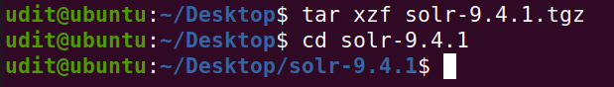

To install Solr as a system service:

sudo bash bin/install_solr_service.sh ~/solr-9.5.0.tgz

OR

sudo bash bin/install_solr_service.sh ~/solr-9.4.1.tgz

V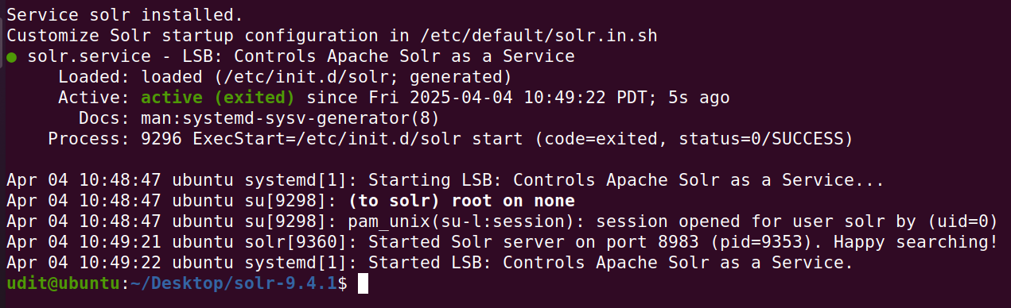

## **2. Run Apache Solr**

After installation, start Solr with:

sudo systemctl start solr

To check if it's running:

sudo systemctl status solr

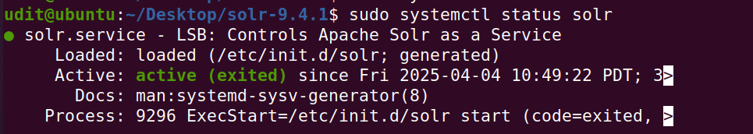

To stop Solr:

sudo systemctl stop solr

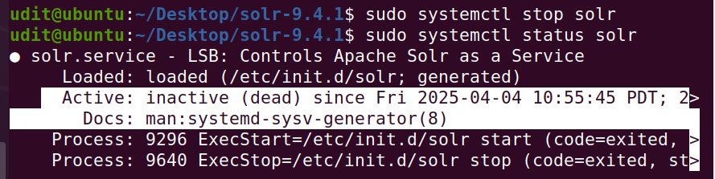

To restart Solr:

sudo systemctl restart solr

To verify Solr is running, open your browser and visit:

<http://localhost:8983/solr>

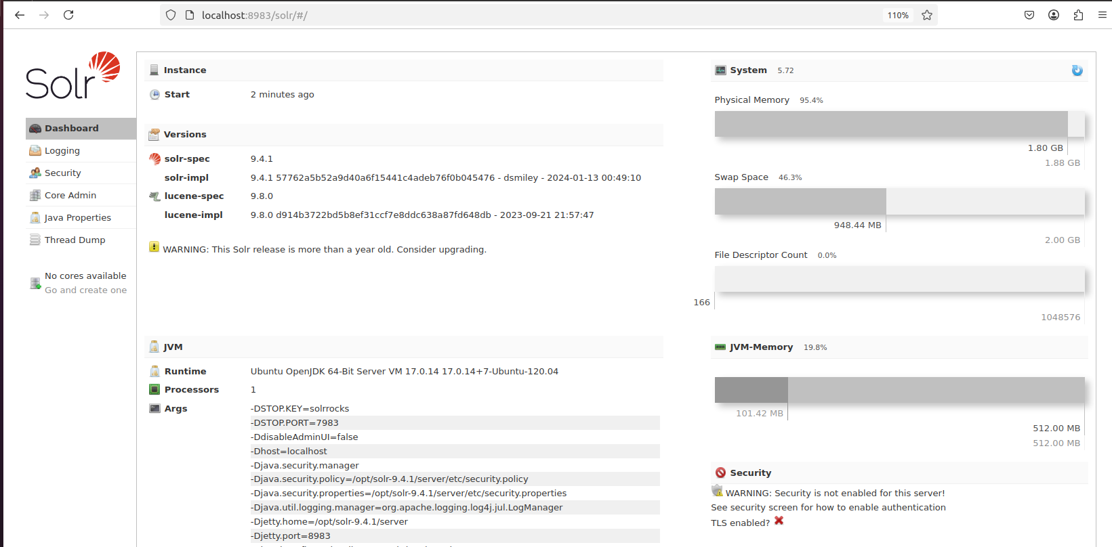

This opens the Solr Admin UI.

## **3. Configure Apache Solr**

### **Create a Collection**

**sudo su - solr**

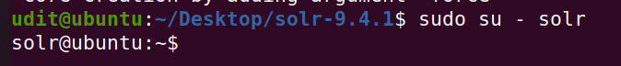

A collection is equivalent to a database in SQL.

/opt/solr/bin/solr create -c mycollection -n _default

Replace mycollection with your preferred name.

/opt/solr/bin/solr create -c mydreams -n _default

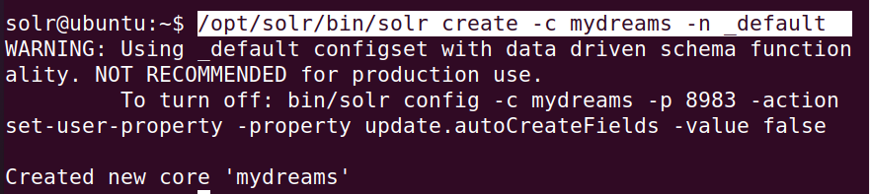

### **🔧 1. Change Solr Configuration**

**Edit Core Config Files**

Solr stores configurations in solrconfig.xml and schema.xml inside:

/var/solr/data/mydreams/conf/



Here’s a concise breakdown of how to **change Solr configuration**, **enable authentication**, **index and search data**, and **monitor logs**.

1. **Common Settings (Global config)**

**File:** /etc/default/solr.in.sh

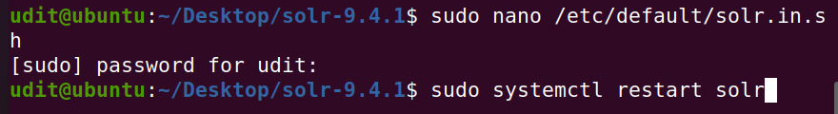

* **Change Port**

**SOLR_PORT=8984**

* **Set Memory**

**SOLR_HEAP="2g"**

**🔐 2. Enable Basic Authentication**

Edit /etc/default/solr.in.sh and add:

**SOLR_AUTH_TYPE="basic"**

**SOLR_AUTHENTICATION_OPTS="-Dbasicauth=admin:admin123"**

Replace admin:admin123 with your preferred username and password.

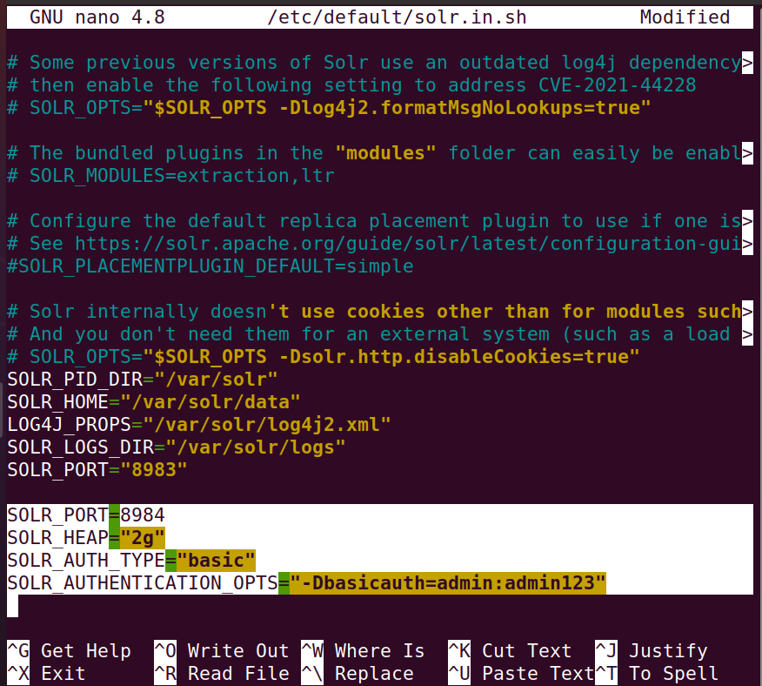

**Restart Solr to Apply Changes**

**sudo systemctl restart solr**

**📥 3. Indexing Data**

**Add a Sample Document**

curl -X POST -H "Content-Type: application/json" --data '

**{**

**"id": "1",**

**"name": "Sample Document"**

**}' http://localhost:8983/solr/ mydreams /update?commit=true**

**🔍 4. Searching Data**

**From Browser**

**http://localhost:8983/solr/ mydreams /select?q=\***

**Using curl**

**curl "http://localhost:8983/solr/mydreams/select?q=*"**

**📈 5. Monitoring Logs**

**Tail Live Logs**

**tail -f /var/solr/logs/solr.log**

You can also check service status:

**sudo systemctl status solr**

### **Next Steps**

* Configure **SolrCloud** for distributed search.
* Integrate Solr with **Elasticsearch** or **Kibana**.
* Use **Solr with Drupal, Magento, or WordPress**.